EX NO:I FREQUENCY RESPONSE AND BANDWIDTH OF COMMON EMITTER AMPLIFIER

AIM:
To construct a common emitter amplifier configuration using BJT and to determine the bandwidth from its frequency response curve.

APPARATUS REQUIRED:

Sl.No | Apparatus | Range | Quantity
1 | Function generator |  | 1
2 | CRO | (0-30MHz) | 1
3 | RPS | (0-30V) | 1
4 | Transistor | BC 547 | 1
5 | Resistor | 1K Ω, 680Ω | 1,1
6 | Capacitor | 4.7uF | 2
7 | Breadboard |  | 1

CIRCUIT DIAGRAM:
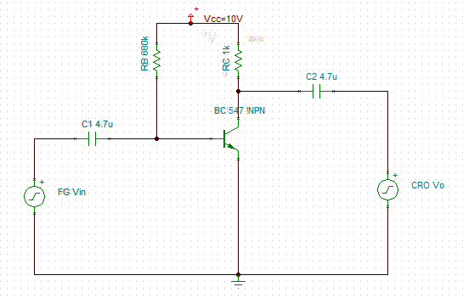

MODEL GRAPH:

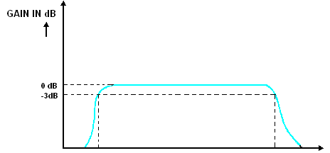
PROCEDURE:

- Connect the circuit as per the circuit diagram
- Set the input and apply the input signal from the FG and observe the output.
- Vary the input frequency from 10Hz to 1MHz and the output amplitude is noted.
- Calculate the gain and draw the frequency response curve.
- Calculate the bandwidth.

TABULATION:
Input Voltage Vin= ...........V
Sl.No | Frequency (HZ) | Output voltage (Volt) | Gain=Vo/Vin | Gain in dB =20log(Vo/Vi)
Calculation:
Bandwidth= f2-f1(Hz)
=................Hz

Result:
Thus the frequency response of common emitter amplifier is obtained and the bandwidth is calculated.
Bandwidth=...............Hz
EX NO:2 FREQUENCY RESPONSE AND BANDWIDTH OF COMMON COLLECTOR AMPLIFIER

AIM:
To construct a common emitter amplifier configuration using BJT and to determine the bandwidth from its frequency response curve.

APPARATUS REQUIRED:

Sl.No | Apparatus | Range | Quantity
1 | Function generator |  | 1
2 | CRO | (0-30MHz) | 1
3 | RPS | (0-30V) | 1
4 | Transistor | BC 547 | 1
5 | Resistor | 33K Ω, 22K Ω, 10KΩ, 1K Ω | Each one
6 | Capacitor | 4.7uF | 2
7 | Breadboard |  | 1
8 | Connecting wires |  | Few

CIRCUIT DIAGRAM :
COMMON COLLECTOR AMPLIFIER
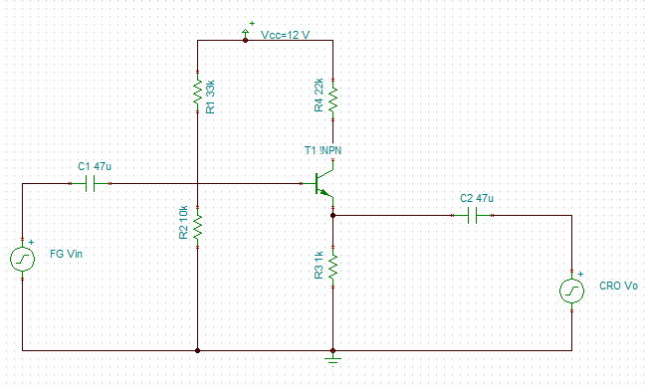

MODEL GRAPH:

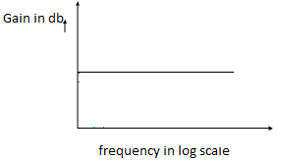

PROCEDURE:
- Connect the circuit as per the circuit diagram.
- Set the input and apply the input signal from the FG and observe the output.
- Vary the input frequency from 10Hz to 1MHz and the output amplitude is noted.
- Calculate the gain and draw the frequency response curve
- Calculate the Bandwidth

TABULATION: Input Voltage Vin= ...........V
Sl.No | Frequency(HZ) | O/P Voltage(V) | Gain=V_{o}/V_{in} | Gain in dB=20log(V_{o}/V_{in} )
Result:
Thus the frequency response of common collector amplifier is obtained.

EX NO:3 FREQUENCY RESPONSE AND BANDWIDTH OF COMMON BASE AMPLIFIER

AIM:
To construct a common base amplifier configuration using BJT and to determine the bandwidth from its frequency response curve.

APPARATUS REQUIRED:

Sl.No | Apparatus | Range | Quantity
1 | Function generator |  | 1
2 | CRO | (0-30MHz) | 1
3 | RPS | (0-30V) | 2
4 | Transistor | BC 547 | 1
5 | Resistor | 20K Ω, 10K Ω, | 1,2
6 | Capacitor | 10uF | 2
7 | Breadboard |  | 1
8 | Connecting wires |  | Few

CIRCUIT DIAGRAM : COMMON BASE AMPLIFIER
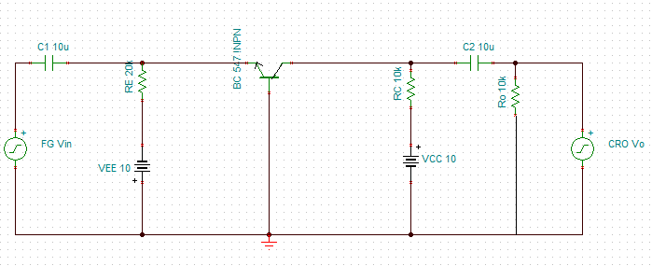

PROCEDURE:
- Connect the circuit as per the circuit diagram.
- Set the input and apply the input signal from the FG and observe the output.
- Vary the input frequency from 10Hz to 1MHz and the output amplitude is noted.
- Calculate the gain and draw the frequency response curve.
- Calculate the bandwidth.

MODEL GRAPH:

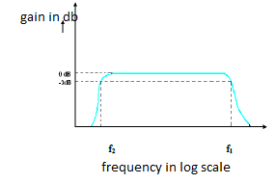
TABULATION:
Input Voltage Vin= ...........V
Sl.No | Frequency (HZ) | Output voltage (Volt) | Gain=Vo/Vin | Gain in dB =20log(Vo/Vi)

Calculation:
Bandwidth= f2-f1
=................Hz

Result:
Thus the frequency response of common base amplifier is obtained and the bandwidth is calculated.
Bandwidth=...............Hz

EX NO:4 FREQUENCY RESPONSE AND BANDWIDTH OF COMMON SOURCE AMPLIFIER

AIM:
To construct a common source amplifier configuration using FET and to determine the bandwidth from its frequency response curve.

APPARATUS REQUIRED:

Sl.No | Apparatus | Range | Quantity
1 | Function generator |  | 1
2 | CRO | (0-30MHz) | 1
3 | RPS | (0-30V) | 2
4 | Transistor | BFW10 | 1
5 | Resistor | 2.2KΩ,10KΩ,1KΩ,1MΩ | Each one
6 | Capacitor | 4.7uF | 2
7 | Breadboard |  | 1
8 | Connecting wires |  | Few

CIRCUIT DIAGRAM : COMMON SOURCE AMPLIFIER
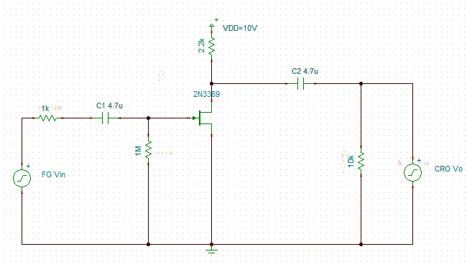
PROCEDURE:
- Connect the circuit as per the circuit diagram.
- Set the input and apply the input signal from the FG and observe the output.
- Vary the input frequency from 10Hz to 1MHz and the output amplitude is noted.
- Calculate the gain and draw the frequency response curve.
- Calculate the bandwidth.

TABULATION: Input Voltage Vin= ...........V
Sl.No | Frequency (HZ) | Output voltage (Volt) | Gain=Vo/Vin | Gain in dB =20log(Vo/Vi)

Calculation:
Bandwidth= f2-f1
=................Hz

MODEL GRAPH:

Result:
Thus the frequency response of common source amplifier is obtained and the bandwidth is calculated.
Bandwidth=...............Hz

EX NO:5 FREQUENCY RESPONSE AND BANDWIDTH OF DARLINGTON
AMPLIFIER
AIM:
To construct a darlington amplifier using BJT and to determine the bandwidth from its frequency response curve.

APPARATUS REQUIRED:

Sl.No | Apparatus | Range | Quantity
1 | Function generator |  | 1
2 | CRO | (0-30MHz) | 1
3 | RPS | (0-30V) | 1
4 | Transistor | BC 547 | 2
5 | Resistor | 10K Ω, 680Ω, 15K Ω | 2,1,1
6 | Capacitor | 4.7uF | 2
7 | Breadboard |  | 1
8 | Connecting wires |  | Few

CIRCUIT DIAGRAM : DARLINGTON AMPLIFIER
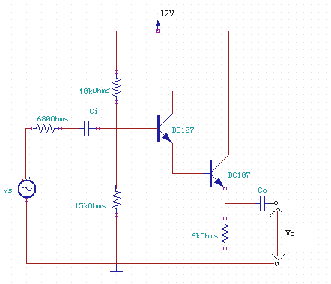

PROCEDURE:
- Connect the circuit as per the circuit diagram.
- Set the input and apply the input signal from the FG and observe the output.
- Vary the input frequency from 10Hz to 1MHz and the output amplitude is noted.
- Calculate the gain and draw the frequency response curve.
- Calculate the bandwidth.
TABULATION: Input Voltage Vin= ...........V
Sl.No | Frequency (HZ) | Output voltage (Volt) | Gain=Vo/Vin | Gain in dB =20log(Vo/Vi)

Calculation:
Bandwidth= f2-f1
=................Hz
MODEL GRAPH:

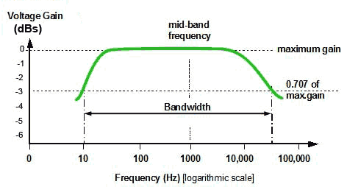
Result:
Thus the frequency response of darlignton amplifier is obtained and the bandwidth is calculated.
Bandwidth=...............Hz

EX NO:6 DIFFERENTIAL AMPLIFIER
–TRANSFER CHARACTERISTICS & CMRR

AIM:
To construct a differential amplifier using BJT and to determine its CMRR from its common mode and difference mode operation.

APPARATUS REQUIRED:

Sl.No | Apparatus | Range | Quantity
1 | Function generator |  | 2
2 | CRO | (0-30MHz) | 1
3 | RPS | (0-30V) | 1
4 | Transistor | BC 547 | 2
5 | Resistor | 4.7K Ω, 10kΩ | 2,1
6 | Breadboard |  | 1
7 | Connecting wires |  | Few

CIRCUIT DIAGRAM :
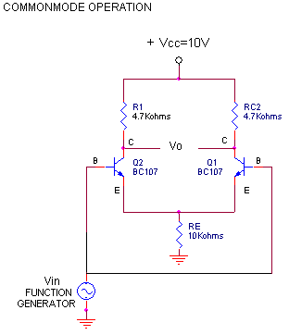
PROCEDURE:

- Connect the circuit as per the circuit diagram.
- Set the input and apply the input signal from the FG and observe the output.
- Vary the input voltage and the output amplitude is noted.
- Calculate the common mode and difference mode gain
- Calculate the CMRR.

TABULATION: DIFFERENTIAL AMPLIFIER-COMMON MODE
V1(V) | V2(V) | Vo(V) | Ac=2Vo/(V1+V2)

CIRCUIT DIAGRAM :
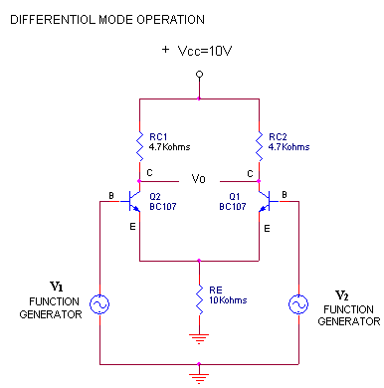

TABULATION: DIFFERENTIAL MODE
V1(V) | V2(V) | Vo(V) | Ad=Vo/(V1-V2)

Result:
Thus the differential amplifier is constructed using BJT and the common mode and difference mode operation is obtained. CMRR is calculated.
CMRR=...............

EXP NO:7 SIMULATION OF COMMON EMITTER AND COMMON SOURCE
AMPLIFIER USING PSPICE SIMULATION SOFTWARE
AIM:
To draw the circuit diagram of common emitter and common source amplifier and to simulate it using PSPICE software.

APPARATUS REQUIRED(simulated):

Sl.No | Apparatus | Range | Quantity
1 | Function generator |  | 1
2 | CRO | (0-30MHz) | 1
3 | RPS | (0-30V) | 1
4 | Transistor | BC 547 | 1
5 | Resistor | 1K Ω, 680Ω | 1,1
6 | Capacitor | 4.7uF | 2
7 | Transistor | BFW10 | 1
8 | Resistor | 2.2KΩ,10KΩ,1KΩ,1MΩ | Each one

PROCEDURE:

- Follow the command to open the capture window.
- Start Program orcade 0.1 capture cs
- In the file menu go to new project
- Give the new project name, path of the project in the dialog box.
- Give the option analog mode of operation
- Add the different component groups from the library object file
- New session file with new page will be opened.
- On the new page paste the component taken from the library object through place port.
- Use wire for connection. Attach the probe at the required point.
- Save the project. Create new simulation file. Choose transient analysis at time = 10ms.
- Run the simulation and the output will be obtained in the simulation window.

A)COMMON EMITTER AMPLIFIER CIRCUIT

B)COMMON SOURCE AMPLIFIER CIRCUIT

Result:
Thus the circuit diagram of common emitter and common source amplifier was drawn and simulated using PSPICE software.

EX NO:8 CLASS –A POWER AMPLIFIER

AIM:
To construct a Class A power amplifier and observe the waveform and to compute maximum output power and efficiency.

APPARATUS REQUIRED:

S.NO | NAME OF THE COMPONENT | RANGES | QUANTITY
 | Transistor | CL100, BC558 | 1,1
 | Resistor | 47k ,33 ,220Ω, | 2,1
 | Capacitor | 47 µ F | 2
 | Signal Generator | (0-3)MHz | 1
 | CRO | 30MHz | 1
 | Regulated power supply | (0-30)V | 1
 | Bread Board |  | 1

CIRCUIT DIAGRAM :

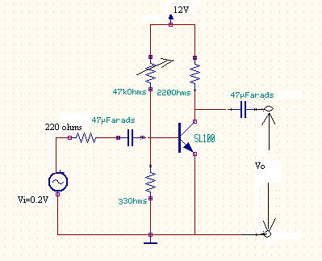

PROCEDURE:

- Connect the circuit as per the circuit diagram.

- Set Vi =50 mv, using the signal generator.

- Keeping the input voltage constant, vary the frequency from 10 Hz to 1M Hz in regular steps and
- note down the corresponding output voltage.

- Plot the graph; Gain (dB) vs Frequency(Hz).

TABULATION: Input Voltage Vin= ...........V
Sl.No | Frequency (HZ) | Output voltage (Volt) | Gain=Vo/Vin | Gain in dB =20log(Vo/Vi)

FORMULA:
Maximum power transfer =Po,max=V 2/R
o L
Effeciency,η = Po,max/Pc

CALCULATION:

RESULT:
Thus the Class A power amplifier was constructed. The following parameters were calculated:
a) Maximum output power= b)Efficiency=

EX NO:9 CLASS –B POWER AMPLIFIER

AIM:
To construct a Class B complementary symmetry power amplifier and observe the waveforms with and without cross-over distortion and to compute maximum output power and efficiency
APPARATUS REQUIRED:

S.NO | NAME OF THE COMPONENT | RANGES | QUANTITY
 | Transistor | CL100, BC558 | 1,1
 | Resistor | 4.7k ,15k | 2,1
 | Capacitor | 100µ F | 2
 | Diode | IN4007 | 2
 | Signal Generator | (0-3)MHz | 1
 | CRO | 30MHz | 1
 | Regulated power supply | (0-30)V | 1
 | Bread Board |  | 1

CIRCUIT DIAGRAM :

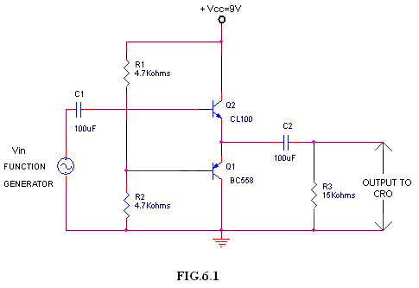
FORMULA
Input power, Pin=2VccIm/П Output power, Pout=VmIm/2
Power Gain or efficiency, η=л/4(Vm/Vcc) 100

MODEL GRAPH :

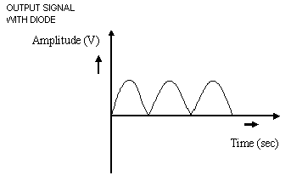

RESULT:

Thus the Class B complementary symmetry power amplifier was constructed to observe cross- over distortion and the circuit was modified to avoid the distortion. The following parameters were calculated:

a)Maximum output power=
b)Efficiency=

EX NO:10 CASCADE AMPLIFIER

AIM:
To construct a cascade amplifier circuit and to plot the frequency response characteristics.
APPARATUS REQUIRED:
S.No. | Name | Range | Quantity
1. | Transistor | BC107 | 1
2. | Resistor | 10kΩ,8 kΩ,500 Ω,100Ω | 1,1,1,1
3. | Regulated power supply | (0-30)V | 1
4. | Signal Generator | (0-3)MHz | 1
5. | CRO | 30 MHz | 1
6. | Capacitor | 0.01µF | 5

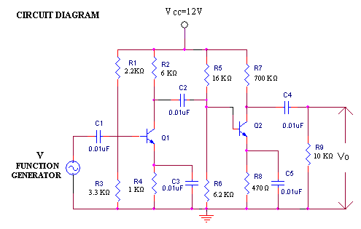
PROCEDURE:
- Connections are made as per the circuit diagram.

- The waveforms at the input and output are observed for cascade operations by varying the input frequency.

- The biasing resistances needed to locate the Q-point are determined.

- Set the input voltage as 1V and by varying the frequency, note the output voltage.

- Calculate gain=20 log (Vo / Vin.)

- A graph is plotted between frequency and gain.

TABULATION: Keep the input voltage constant (Vin) =
Frequency (in Hz) | Output Voltage (in volts) | Gain = 20 log (Vo / Vin) (in dB)

MODEL GRAPH
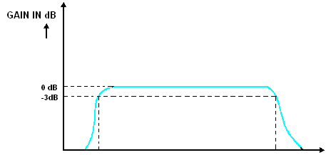

RESULT:
Thus, the Cascade amplifier was constructed and the gain was determined.

EX NO:11 CASCODE AMPLIFIER

AIM:
To construct a cascode amplifier circuit and to plot the frequency response characteristics.
APPARATUS REQUIRED:

S.No. | Name | Range | Quantity
1. | Transistor | BC107 | 2
2. | Resistor | 22kΩ,6 kΩ,700 Ω,470Ω  16 kΩ,6.2 kΩ,3.3 kΩ 1.1 kΩ | 1,1,1,1,  1,1,1,1
3. | Regulated power supply | (0-30)V | 1
4. | Signal Generator | (0-3)MHz | 1
5. | CRO | 30 MHz | 1
6. | Capacitor | 0.01µF | 3

CIRCUIT DIAGRAM
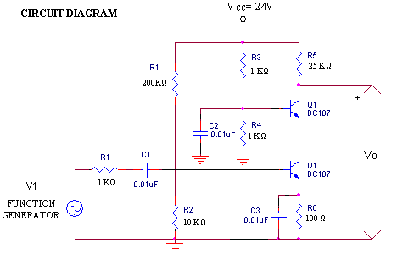

PROCEDURE:
1. Connections are made as per the circuit diagram.
2. The waveforms at the input and output are observed for cascode operations by varying the input frequency.
3. The biasing resistances needed to locate the Q-point are determined.
4. Set the input voltage as 1V and by varying the frequency, note the output voltage.
5. Calculate gain=20 log (Vo / Vin.)
6. A graph is plotted between frequency and gain.

TABULATION:
Keep the input voltage constant (Vin) =
Frequency (in Hz) | Output Voltage (in volts) | Gain = 20 log (Vo / Vin) (in dB)

MODEL GRAPH
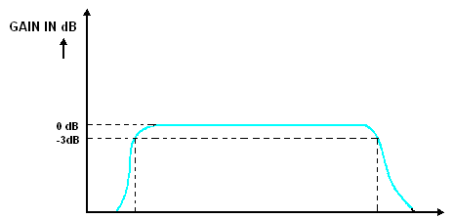

RESULT:
Thus, the Cascode amplifier was constructed and the gain was determined

