INTRODUCTION

There are 3 hours allocated to a laboratory session in. It is a necessary part of the course at which attendance is compulsory.
Here are some guidelines to help you perform the experiments and to submit the reports:

1. Read all instructions carefully and carry them all out.

2. Ask a demonstrator if you are unsure of anything.

3. Record actual results (comment on them if they are unexpected!)

4. Write up full and suitable conclusions for each experiment.

5. If you have any doubt about the safety of any procedure, contact the demonstrator beforehand.

INTRODUCTION ABOUT DIGITAL IC TRAINER KIT

Digital IC Trainer (VBET - 21) is an assembly of instruments required in analog and digital electronic experiments. This is equivalent to a complete laboratory set-up except an oscilloscope. This trainer will enable the users to understand and test the IC‟s and help the engineer to test the circuits developed.

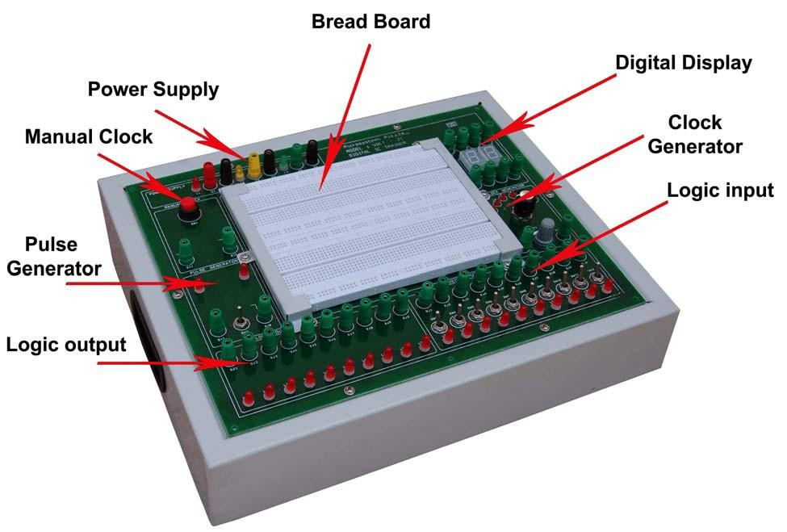

It contains the following sections,
1. Solder less bread board:
Used for testing 14/16 pin digital IC‟s of 54 and 74 series. It is also used for testing digital circuits.
2. Clock generator:
The clock signal is generated and the frequency is externally variable. The frequency is chosen to provide perceptible indication on the counter.
3. Pulse generator:
The clock signal is generated and the frequency is externally variable by using slide switch.
4. Manual clock:
The clock signal is generated manually by using push button.
5. Logic input:
Logic level of high or low input is made through slide switches. The LED‟s are provided to show the logic level of high or low output.
6. Logic output:
The LED of the section is used to show the output.
7. Seven segment display:
It displays the BCD count from (0-9) by giving the output.

THE BREADBOARD
The breadboard consists of two terminal strips and two bus strips (often broken in the centre). Each bus strip has two rows of contacts. Each of the two rows of contacts are a node. That is, each contact along a row on a bus strip is connected together (inside the breadboard). Bus strips are used primarily for power supply connections, but are also used for any node requiring a large number of connections. Each terminal strip has 60 rows and 5 columns of contacts on each side of the centre gap. Each row of 5 contacts is a node.

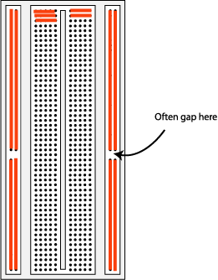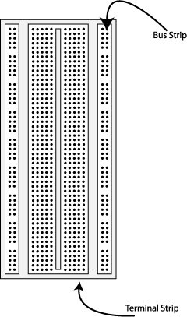

Fig. The breadboard. The lines indicate connected holes.

You will build your circuits on the terminal strips by inserting the leads of circuit components into the contact receptacles and making connections with 22-26 gauge wire. There are wire cutter/strippers and a spool of wire in the lab. It is a good practice to wire +5V and 0V power supply connections to separate bus strips.

The 5V supply MUST NOT BE EXCEEDED since this will damage the ICs (Integrated circuits) used during the experiments. Incorrect connection of power to the ICs could result in them exploding or becoming very hot - with the possible serious injury occurring to the people working on the experiment! Ensure that the power supply polarity and all components and connections are correct before switching on power.

BUILDING THE CIRCUIT

Throughout these experiments we will use TTL chips to build circuits. The steps for wiring a circuit should be completed in the order described below:

- Turn the power (Trainer Kit) off before you build anything!
- Make sure the power is off before you build anything!
- Connect the +5V and ground (GND) leads of the power supply to the power and ground bus strips on your breadboard.
- Plug the chips you will be using into the breadboard. Point all the chips in the same direction with pin 1 at the upper-left corner. (Pin 1 is often identified by a dot or a notch next to it on the chip package)
- Connect +5V and GND pins of each chip to the power and ground bus strips on the breadboard.
- Select a connection on your schematic and place a piece of hook-up wire between corresponding pins of the chips on your breadboard. It is better to make the short connections before the longer ones. Mark each connection on your schematic as you go, so as not to try to make the same connection again at a later stage.
- Get one of your group members to check the connections, before you turn the power on.
- If an error is made and is not spotted before you turn the power on. Turn the power off immediately before you begin to rewire the circuit.
- At the end of the laboratory session, collect you hook-up wires, chips and all equipment and return them to the demonstrator.
- Tidy the area that you were working in and leave it in the same condition as it was before you started.

COMMON CAUSES OF PROBLEMS

- Not connecting the ground and/or power pins for all chips.
- Not turning on the power supply before checking the operation of the circuit.
- Leaving out wires.
- Plugging wires into the wrong holes.
- Driving a single gate input with the outputs of two or more gates
- Modifying the circuit with the power on.

In all experiments, you will be expected to obtain all instruments, leads, components at the start of the experiment and return them to their proper place after you have finished the experiment. Please inform the demonstrator or technician if you locate faulty equipment. If you damage a chip, inform a demonstrator, don't put it back in the box of chips for somebody else to use.

DIGITAL INTEGRATED CIRCUITS (ICs)

The digital integrated circuits are a collection of large number of resistors, diodes and transistors
fabricated on a single piece of silicon called a substrate. This substrate with integrated components on it usually referred as a “chip”. The most common type of package is a dual-in-line package (DIP) is shown below. It is so called as it contains two parallel rows of pins. The pins are numbered in a counterclockwise fashion when viewed from the top.

Notch

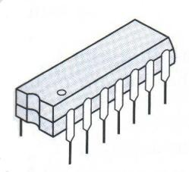Small dot
14 13 12 11 10 9 8

1 2 3 4 5 6 7
- (b)

(a) Dual-in-line package; (b) top view of chip.
STUDY OF LOGIC GATES

AIM

To study about logic gates and verify their truth tables

APPARATUS REQUIRED

1. AND GATE IC 7408
2. OR GATE IC 7432
3. NOT GATE IC 7404
4. NAND GATE 2 I/P IC 7400
5. NOR GATE IC 7402
6. X-OR GATE IC 7486
7. NAND GATE 3 I/P IC 7410
8. IC TRAINER KIT - 1

THEORY
Circuit that takes the logical decision and the process are called logic gates. Each gate has
one or more input and only one output. OR, AND and NOT are basic gates. NAND, NOR and X- OR are known as universal gates. Basic gates form these gates.
AND GATE
The AND gate performs a logical multiplication commonly known as AND function. The
output is high when both the inputs are high. The output is low level when any one of the inputs is low.
OR GATE
The OR gate performs a logical addition commonly known as OR function. The output is
high when any one of the inputs is high. The output is low level when both the inputs are low.
NOT GATE
The NOT gate is called an inverter. The output is high when the input is low. The output is
low when the input is high.
NAND GATE
The NAND gate is a contraction of AND-NOT. The output is high when both inputs are
low and any one of the input is low .The output is low level when both inputs are high.
NOR GATE
The NOR gate is a contraction of OR-NOT. The output is high when both inputs are low.
The output is low when one or both inputs are high.
X-OR GATE
The output is high when any one of the inputs is high. The output is low when both the
inputs are low and both the inputs are high.

PROCEDURE
- Connections are given as per circuit diagram.
- Logical inputs are given as per circuit diagram.
- Observe the output and verify the truth table.

AND GATE NOT GATE OR GATE
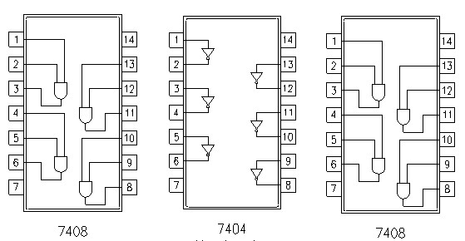

X-OR GATE 2-INPUT NAND GATE

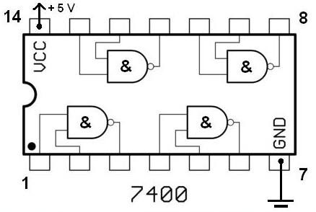

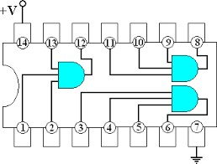3-INPUT AND GATE
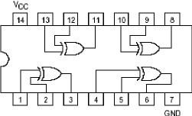

3-INPUT NOR GATE 3-INPUT NAND GATE
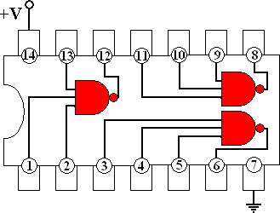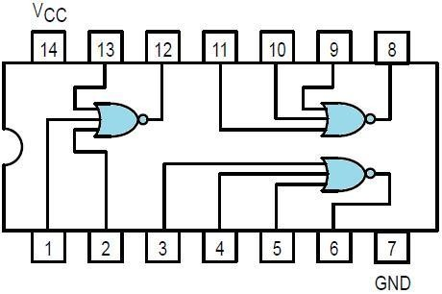

RESULT:

Thus the study of logic gates have been completed successfully
EX.NO: 1 DATE:

DESIGN AND IMPLEMENTATION OF CODE CONVERTERS USING LOGIC GATES

BCD TO EXCESS – 3 & EXCESS – 3 TO BCD CODE CONVERSION

AIM: -

To convert the given BCD numbers to Excess - 3 codes and vice versa

APPARATUS REQUIRED: -

S.No. | Name of the apparatus | Range | Quantity
1 | Digital Trainer kit |  | 1
2 | OR gate | IC 7432 | 2
3 | AND gate | IC 7408 | 2
4 | 3-Input AND gate | IC 7411 | 1
5 | NOT gate | IC 7404 | 1
6 | Ex-OR gate | IC 7486 | 1
7 | Connecting wires |  | some

BCD TO EXCESS-3 CODE CONVERTER:
Truth Table:

Decimal  No. | BCD |  |  |  | Excess 3
 | B3 | B2 | B1 | B0 | E3 | E2 | E1 | E0
0 | 0 | 0 | 0 | 0 | 0 | 0 | 1 | 1
1 | 0 | 0 | 0 | 1 | 0 | 1 | 0 | 0
2 | 0 | 0 | 1 | 0 | 0 | 1 | 0 | 1
3 | 0 | 0 | 1 | 1 | 0 | 1 | 1 | 0
4 | 0 | 1 | 0 | 0 | 0 | 1 | 1 | 1
5 | 0 | 1 | 0 | 1 | 1 | 0 | 0 | 0
6 | 0 | 1 | 1 | 0 | 1 | 0 | 0 | 1
7 | 0 | 1 | 1 | 1 | 1 | 0 | 1 | 0
8 | 1 | 0 | 0 | 0 | 1 | 0 | 1 | 1
9 | 1 | 0 | 0 | 1 | 1 | 1 | 0 | 0

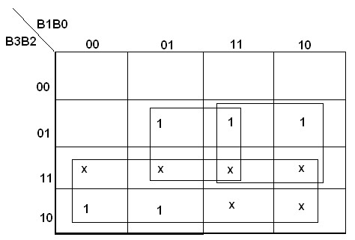K-Map for E3:

K-Map for E2:
E3 = B3 + B2 (B0 + B1)

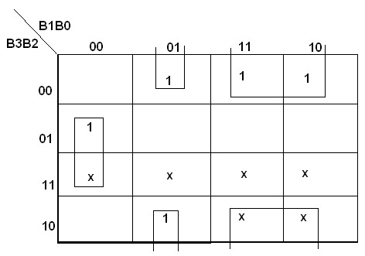

K-Map for E1:

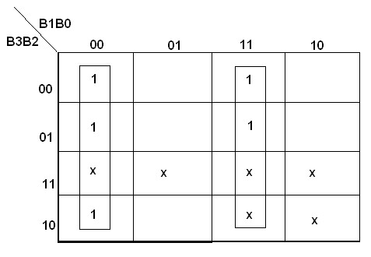

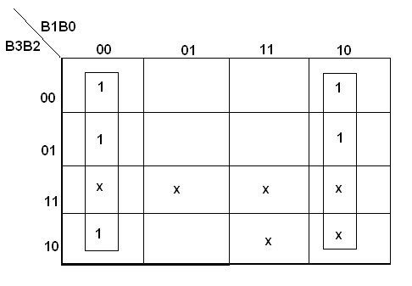K-Map for E0:

BCD TO EXCESS-3 CONVERTOR

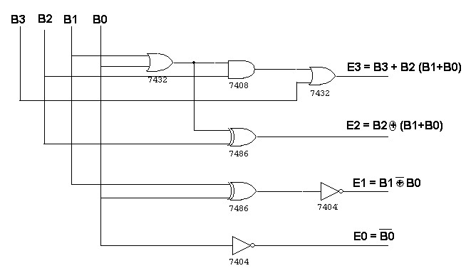
Excess – 3 Input |  |  |  | BCD Output
E3 | E2 | E1 | E0 | B3 | B2 | B1 | B0
0  0  0  0  0  1  1  1  1  1 | 0  1  1  1  1  0  0  0  0  1 | 1  0  0  1  1  0  0  1  1  0 | 1  0  1  0  1  0  1  0  1  0 | 0  0  0  0  0  0  0  0  1  1 | 0  0  0  0  1  1  1  1  0  0 | 0  0  1  1  0  0  1  1  0  0 | 0  1  0  1  0  1  0  1  0  1

K-Map for B3:

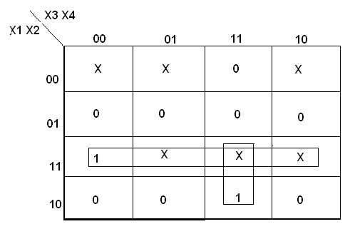

A = X1 X2 + X3 X4 X1

K-Map for B2:

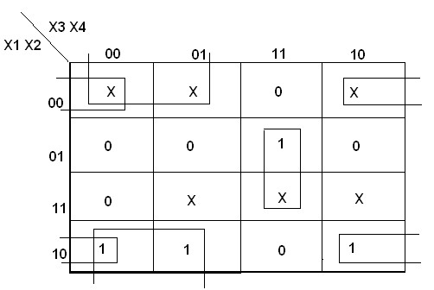

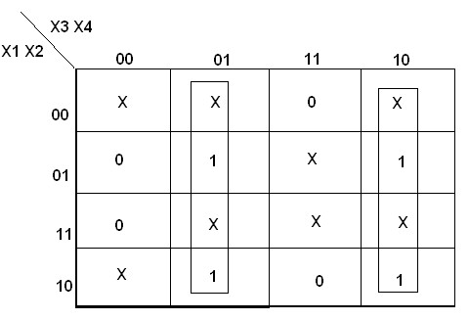K-Map for B1:

K-Map for B0:

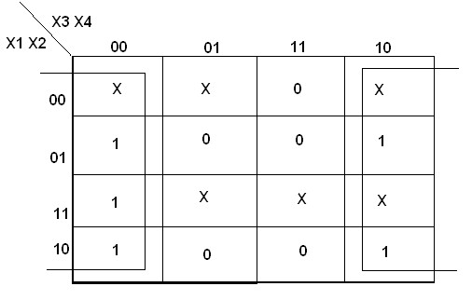

EXCESS-3 TO BCD CONVERTER

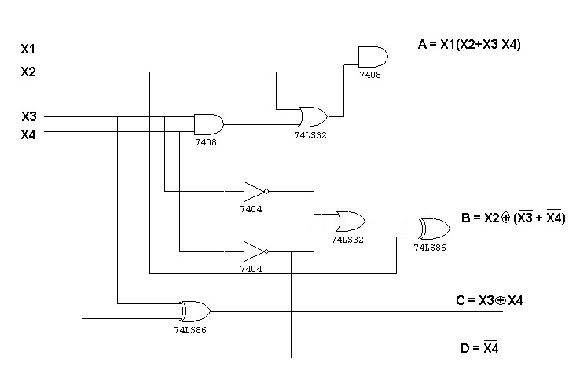
PROCEDURE:

- Convert BCD to EXCESS-3 code and EXCESS-3 code to BCD by the procedure given above.
- Perform the K-Map Simplification
- Draw the logic diagram for the K-Map simplified output.
- Use various Logic GATES and breadboard to implement the circuit.

RESULT:
Thus the Code conversion of BCD to Excess-3 and vice versa was verified successfully

EX.NO: 2 DATE:

BINARY TO GRAY & GRAY TO BINARYCODE CONVERSION
AIM: -

To convert given binary numbers to gray codes and vice versa

APPARATUS REQUIRED: -

S.No. | Name of the apparatus | Range | Quantity
1 | Digital Trainer kit |  | 1
2 | Ex-OR gate | IC 7486 | 1
3 | Connecting wires |  | some

BINARY TO GRAY CODE CONVERSION:

BINARY 1 1 0 1

+

GRAY 1 0 1 1 1

G3 G2 G1 G0

Truth Table

Binary |  |  |  | Gray
B3 | B2 | B1 | B0 | G3 | G2 | G1 | G0
0  0  0  0  0  0  0  0  1  1  1  1  1  1  1  1 | 0  0  0  0  1  1  1  1  0  0  0  0  1  1  1  1 | 0  0  1  1  0  0  1  1  0  0  1  1  0  0  1  1 | 0  1  0  1  0  1  0  1  0  1  0  1  0  1  0  1 | 0  0  0  0  0  0  0  0  1  1  1  1  1  1  1  1 | 0  0  0  0  1  1  1  1  1  1  1  1  0  0  0  0 | 0  0  1  1  1  1  0  0  0  0  1  1  1  1  0  0 | 0  1  1  0  0  1  1  0  0  1  1  0  0  1  1  0

BINARY TO GRAY CODE CONVERTOR:

K-Map for G3:

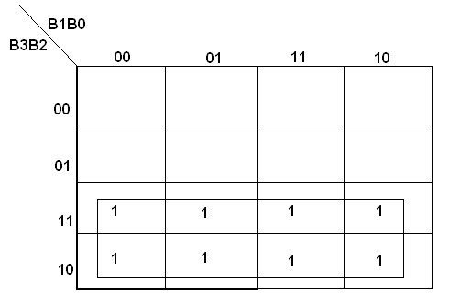

G3=B3

K-Map for G2:
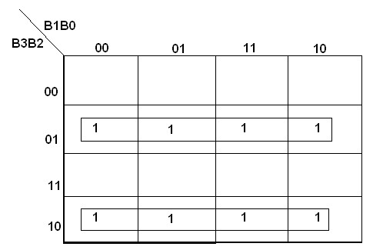

K-Map for G1:

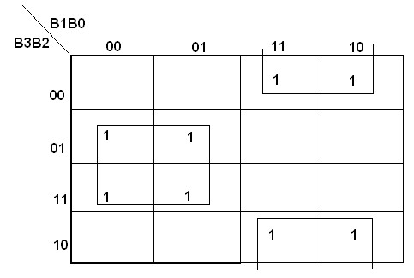

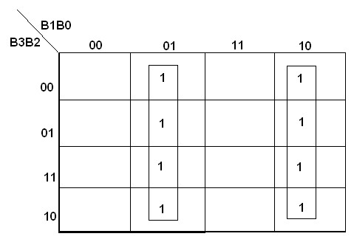K-Map for G0:

Binary to gray code converter:

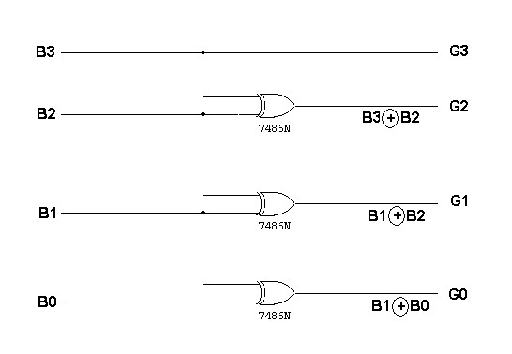

Truth Table: Gray to Binary

G3 | G2 | G1 | G0 | B3 | B2 | B1 | B0
0  0  0  0  0  0  0  0  1  1  1  1  1  1  1  1 | 0  0  0  0  1  1  1  1  1  1  1  1  0  0  0  0 | 0  0  1  1  1  1  0  0  0  0  1  1  1  1  0  0 | 0  1  1  0  0  1  1  0  0  1  1  0  0  1  1  0 | 0  0  0  0  0  0  0  0  1  1  1  1  1  1  1  1 | 0  0  0  0  1  1  1  1  0  0  0  0  1  1  1  1 | 0  0  1  1  0  0  1  1  0  0  1  1  0  0  1  1 | 0  1  0  1  0  1  0  1  0  1  0  1  0  1  0  1

K-Map for B3:
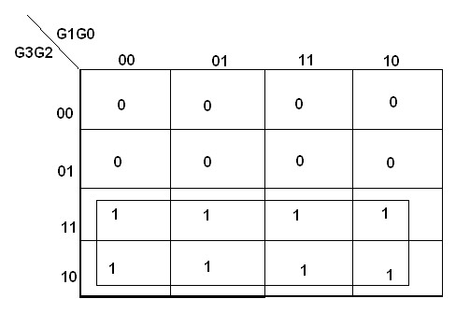

B3 = G3

K-Map for B2:
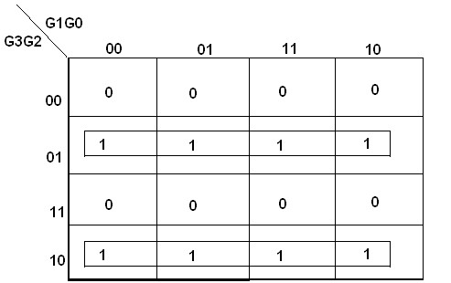

K-Map for B1:
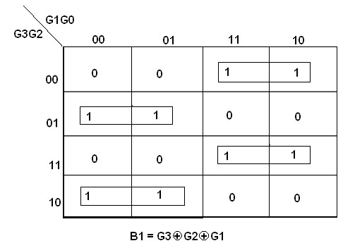

K-Map for B0:
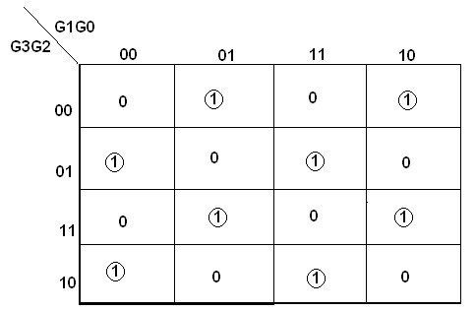

B0=G3®G2®G1®G0

GRAY CODE TO BINARY CONVERTOR

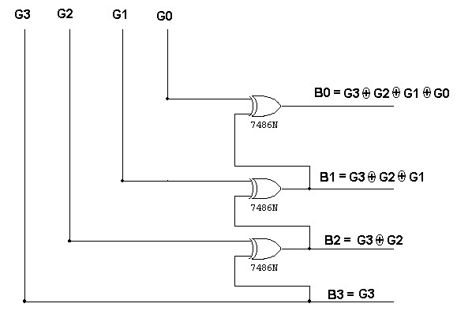

PROCEDURE:
- The circuit connections are made as shown in fig.
- Pin (14) is connected to +Vcc and Pin (7) to ground.
- In the case of binary to gray conversion, the inputs B0, B1, B2 and B3 are given at respective pins and outputs G0, G1, G2, and G3 are taken for all the 16 combinations of the input.
- In the case of gray to binary conversion, the inputs G0, G1, G2 and G3 are given at respective pins and outputs B0, B1, B2, and B3 are taken for all the 16 combinations of inputs.
- The values of the outputs are tabulated.

RESULT:

Thus the code conversion of Binary to Gray and vice versa have done successfully
EX.NO: 3 DATE:

DESIGN AND IMPLEMENTATION OF 4-BIT BINARY ADDER / SUBTRACTOR

AND BCD ADDER USING IC7483
AIM:

To study the 4 bit binary adder / subtractor and BCD adder using IC7483.

APPARATUS REQUIRED

S.No. | Name of the apparatus | Range | Quantity
1 | Digital Trainer kit |  | 1
2 | OR gate | IC 7432 | 1
3 | AND gate | IC 7408 | 1
4 | Binary Adder / Subtractor | IC 7483 | 2
5 | Connecting wires |  | some

FUNCTIONAL DIAGRAM OF IC 7483

Operand1 Operand2

B3 B2 B1 B0 A3 A2 A1A0

4 bit IC 7483

O/P

PIN DIAGRAM OF IC 7483
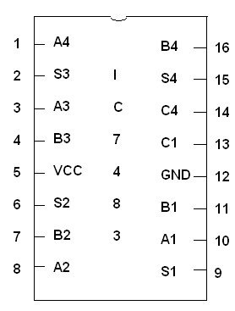

4-BIT BINARY ADDER:
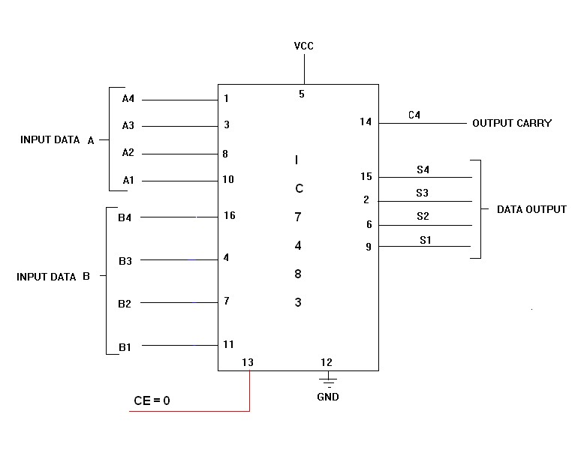

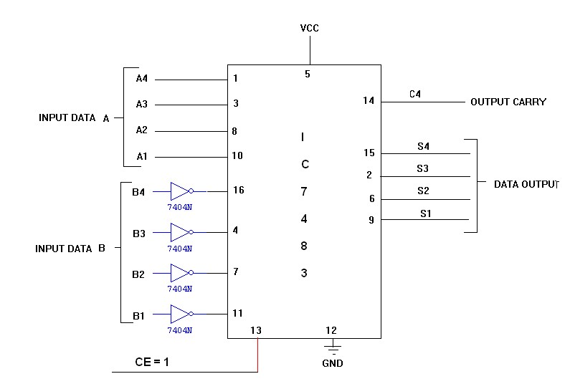4-BIT BINARY SUBTRACTOR:

4-BIT BINARY ADDER/SUBTRACTOR
TRUTH TABLE

Input Data A |  |  |  | Input Data B |  |  |  | Addition |  |  |  |  | Subtraction
A4 | A3 | A2 | A1 | B4 | B3 | B2 | B1 | C | S4 | S3 | S2 | S1 | B | D4 | D3 | D2 | D1
1 | 0 | 0 | 0 | 0 | 0 | 1 | 0 | 0 | 1 | 0 | 1 | 0 | 1 | 0 | 1 | 1 | 0
1 | 0 | 0 | 0 | 1 | 0 | 0 | 0 | 1 | 0 | 0 | 0 | 0 | 1 | 0 | 0 | 0 | 0
0 | 0 | 1 | 0 | 1 | 0 | 0 | 0 | 0 | 1 | 0 | 1 | 0 | 0 | 1 | 0 | 1 | 0
0 | 0 | 0 | 1 | 0 | 1 | 1 | 1 | 0 | 1 | 0 | 0 | 0 | 0 | 1 | 0 | 1 | 0
1 | 0 | 1 | 0 | 1 | 0 | 1 | 1 | 1 | 0 | 0 | 1 | 0 | 0 | 1 | 1 | 1 | 1
1 | 1 | 1 | 0 | 1 | 1 | 1 | 1 | 1 | 1 | 0 | 1 | 0 | 0 | 1 | 1 | 1 | 1
1 | 0 | 1 | 0 | 1 | 1 | 0 | 1 | 1 | 0 | 1 | 1 | 1 | 0 | 1 | 1 | 0 | 1

LOGIC DIAGRAM
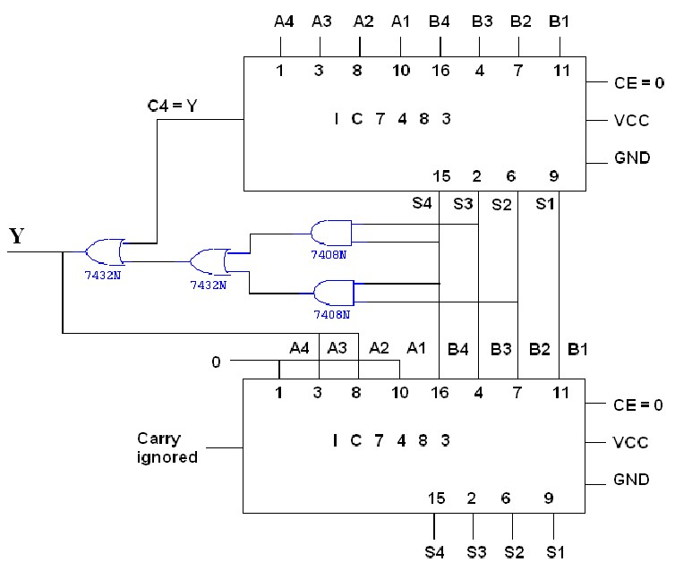

PROCEDURE:

- Connections are given as per the circuit diagram.
- Set mode M =0 such that the circuit will operate in addition mode.
- Set the Value of inputs A as 1001 and B as 1001 note the sum and output carry.
- Repeat the same step in step 3 by keeping M=1 such that circuit will operate in subtraction mode.

RESULT:

Thus the 4 bit binary adder / subtractor and BCD adder using IC7483 was verified successfully
EX.NO: 4 DATE:

DESIGN AND IMPLEMENTATION OF MULTIPLEXER & DEMULTIPLEXER
USING LOGIC GATES

AIM

To design and implement multiplexer and de-multiplexer using logic gates

APPARATUS REQUIRED

S.No. | Name of the apparatus | Range | Quantity
1 | Digital Trainer kit
2 | OR gate | IC7432 | 1
3 | AND gate | IC7411 | 1
4 | NOT gate | IC7404 | 1
5 | Connecting wires

4-1 MULTIPLEXER SYMBOL
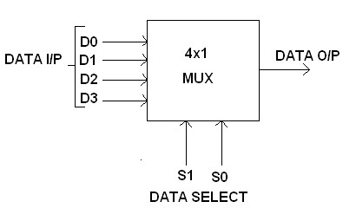

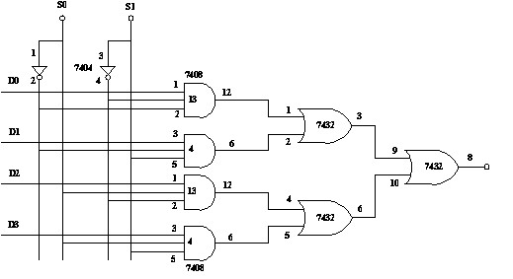 CIRCUIT DIAGRAM:
FUNCTION TABLE

S0 | S1 | D0 | D1 | D2 | D3 | O/P
0 | 0 | 1 | X | X | X | 1
0 | 0 | 0 | X | X | X | 0
0 | 1 | X | 1 | X | X | 1
0 | 1 | X | 0 | X | X | 0
1 | 0 | X | X | 1 | X | 1
1 | 0 | X | X | 0 | X | 0
1 | 1 | X | X | X | 1 | 1
1 | 1 | X | X | X | 0 | 0

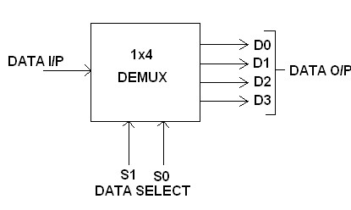

FUNCTION TABLE

S1 | S0 | INPUT
0 | 0 | X → D0 = X S1‟ S0‟
0 | 1 | X → D1 = X S1‟ S0
1 | 0 | X → D2 = X S1 S0‟
1 | 1 | X → D3 = X S1 S0

Y = X S1‟ S0‟ + X S1‟ S0 + X S1 S0‟ + X S1 S0
CONNECTION DIAGRAM OF 16-1 MULTIPLEXER USING IC74150
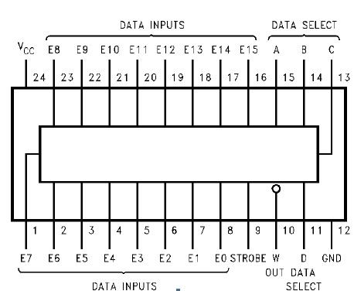

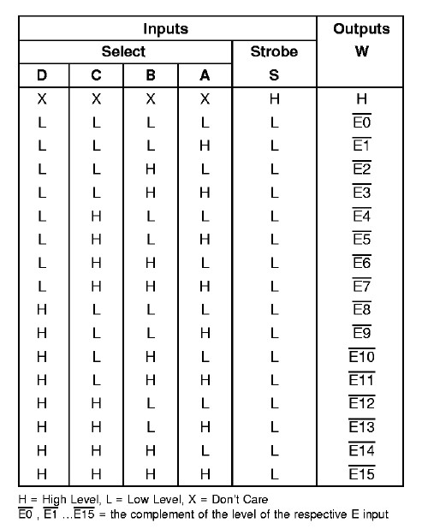FUNCTION TABLE
2-4 DEMULTIPLEXERS

E | B | A | D0 | D1 | D2 | D3
1 | 0 | 0 | 1 | 0 | 0 | 0
1 | 0 | 1 | 0 | 1 | 0 | 0
1 | 1 | 0 | 0 | 0 | 1 | 0
1 | 1 | 1 | 0 | 0 | 0 | 1

LOGIC DIAGRAM

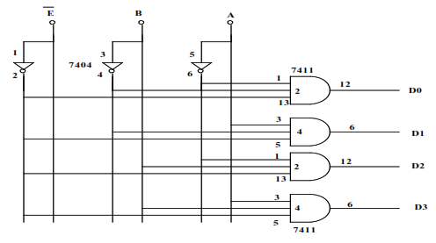
PIN DIAGRAM FOR IC 74154

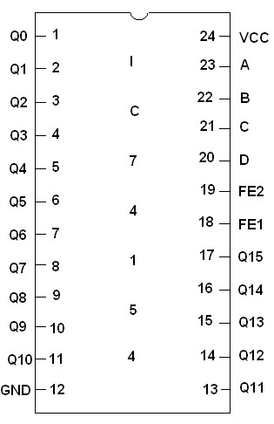

CONNECTION DIAGRAM OF 4-16 DEMULTIPLEXER USING IC74154

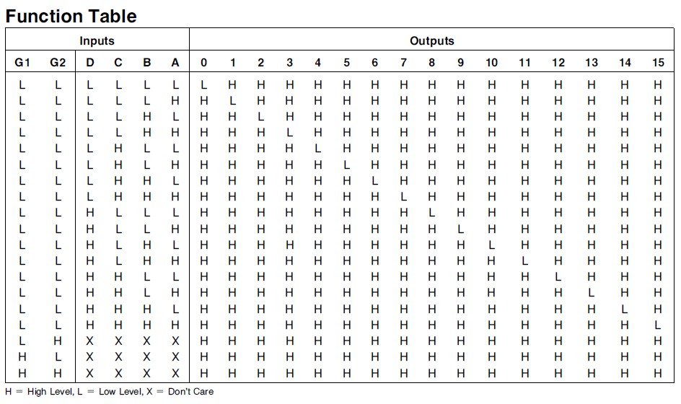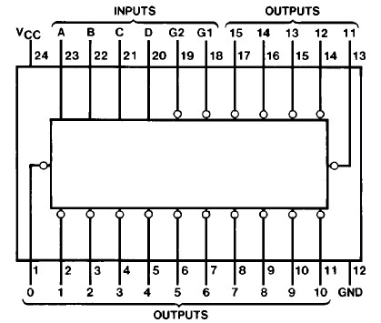

PROCEDURE

- Connections are given as per in the circuit diagram.

- Inputs are given through the logic switches.

- Outputs are noted and verified with truth table

RESULT:

Thus the Multiplexer & De-multiplexer has been done and verified successfully

EX.NO: 5 DATE:

DESIGN AND IMPLEMENTATION OF ENCODER AND DECODER

AIM

To design and implement encoder and decoder using logic gates

APPARATUS REQUIRED

S.No. | COMPONENT | SPECIFICATION | QTY.
1. | AND GATE | IC 7410 | 1
2. | OR GATE | IC 7432 | 1
3. | NOT GATE | IC 7404 | 1
2. | IC TRAINER KIT | - | 1
3. | PATCH CORDS | - | -

4X2 ENCODER CIRCUIT

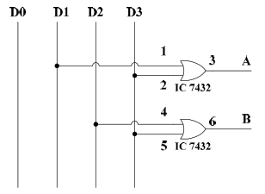

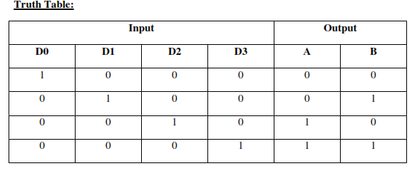

2X4 DECODER CIRCUIT

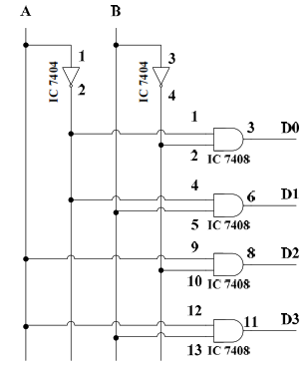

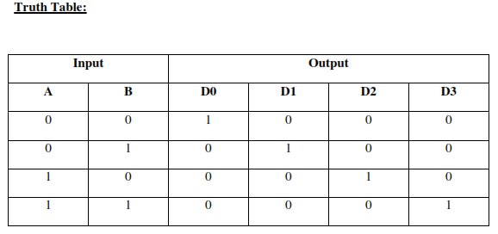

BCD TO DECIMAL DECODER

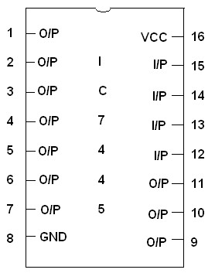PIN DIAGRAM FOR IC 7445

CONNECTION DIAGRAM OF BCD TO DECIMAL DECODER USING IC7445

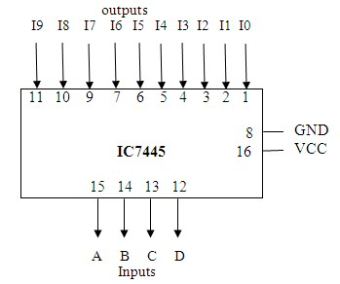
TABLE:

INPUTS |  |  |  | OUTPUTS
A | B | C | D | Y0 | Y1 | Y2 | Y3 | Y4 | Y5 | Y6 | Y7 | Y8 | Y9
0 | 0 | 0 | 0 | 0 | 1 | 1 | 1 | 1 | 1 | 1 | 1 | 1 | 1
0 | 0 | 0 | 1 | 1 | 0 | 1 | 1 | 1 | 1 | 1 | 1 | 1 | 1
0 | 0 | 1 | 0 | 1 | 1 | 0 | 1 | 1 | 1 | 1 | 1 | 1 | 1
0 | 0 | 1 | 1 | 1 | 1 | 1 | 0 | 1 | 1 | 1 | 1 | 1 | 1
0 | 1 | 0 | 0 | 1 | 1 | 1 | 1 | 0 | 1 | 1 | 1 | 1 | 1
0 | 1 | 0 | 1 | 1 | 1 | 1 | 1 | 1 | 0 | 1 | 1 | 1 | 1
0 | 1 | 1 | 0 | 1 | 1 | 1 | 1 | 1 | 1 | 0 | 1 | 1 | 1
0 | 1 | 1 | 1 | 1 | 1 | 1 | 1 | 1 | 1 | 1 | 0 | 1 | 1
1 | 0 | 0 | 0 | 1 | 1 | 1 | 1 | 1 | 1 | 1 | 1 | 0 | 1
1 | 0 | 0 | 1 | 1 | 1 | 1 | 1 | 1 | 1 | 1 | 1 | 1 | 0

PROCEDURE

- Connections are given as per circuit diagram
- Logical inputs are given as per circuit diagram
- Observe the output and verify the truth table.

10 LINE TO 4 LINE PRIORITY ENCODER

CONNECTION DIAGRAM OF IC74147
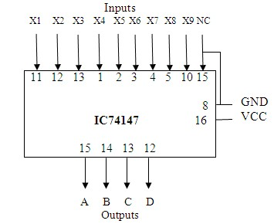
FUNCTION TABLE

INPUTS |  |  |  |  |  |  |  |  | OUTPUTS
I1 | I2 | I3 | I4 | I5 | I6 | I7 | I8 | I9 | A3 | A2 | A1 | A0
H | H | H | H | H | H | H | H | H | H | H | H | H
X | X | X | X | X | X | X | X | L | L | H | H | L
X | X | X | X | X | X | X | L | H | L | H | H | H
X | X | X | X | X | X | L | H | H | H | L | L | L
X | X | X | X | X | L | H | H | H | H | L | L | H
X | X | X | X | L | H | H | H | H | H | L | H | L
X | X | X | L | H | H | H | H | H | H | L | H | H
X | X | L | H | H | H | H | H | H | H | H | L | L
X | L | H | H | H | H | H | H | H | H | H | L | H
L | H | H | H | H | H | H | H | H | H | H | H | L

RESULT:

Thus the Encoder and Decoder have done and verified successfully.
EX.NO: 6 DATE:

CONSTRUCTION AND VERIFICATION OF 4 BIT RIPPLE COUNTER AND MOD
10/MOD 12 RIPPLE COUNTER

AIM

To design and verify 4 bit ripple counter mod 10/ mod 12 ripple counter.

APPARATUS REQUIRED

S.No. | COMPONENT | SPECIFICATION | QTY.
1. | JK FLIP FLOP | IC 7476 | 2
2. | NAND GATE | IC 7400 | 1
3. | IC TRAINER KIT | - | 1
4. | PATCH CORDS | - | 30

THEORY

A counter is a register capable of counting number of clock pulse arriving at its clock input. Counter represents the number of clock pulses arrived. A specified sequence of states appears as counter output. This is the main difference between a register and a counter. There are two types of counter, synchronous and asynchronous. In synchronous common clock is given to all flip flop and in asynchronous first flip flop is clocked by external pulse and then each successive flip flop is clocked by Q or Q’ output of previous stage. A soon the clock of second stage is triggered by output of first stage. Because of inherent propagation delay time all flip flops are not activated at same time which results in asynchronous operation.

4-bit ripple counter which follows a sequence of 16 states can be converted into Mod-

10(decade counter) and Mod-12 counter using simple feed back loop. Decade counter follows a sequence of ten states and returns to 0 after the count of 9. Mod-12 counter follows a sequence of
12 states and returns to 0 after the count of 11.

PIN DIAGRAM FOR IC 7476

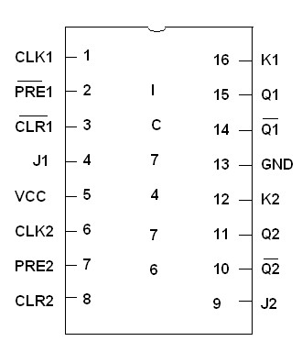

LOGIC DIAGRAM FOR 4 BIT RIPPLE COUNTER

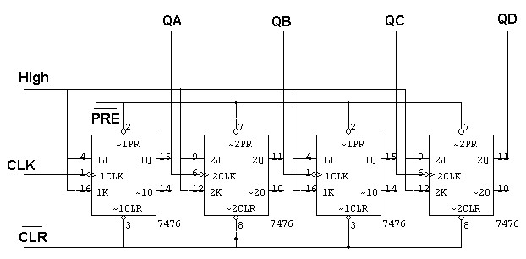

TRUTH TABLE

CLK | QA | QB | QC | QD
0 | 0 | 0 | 0 | 0
1 | 1 | 0 | 0 | 0
2 | 0 | 1 | 0 | 0
3 | 1 | 1 | 0 | 0
4 | 0 | 0 | 1 | 0
5 | 1 | 0 | 1 | 0
6 | 0 | 1 | 1 | 0
7 | 1 | 1 | 1 | 0
8 | 0 | 0 | 0 | 1
9 | 1 | 0 | 0 | 1
10 | 0 | 1 | 0 | 1
11 | 1 | 1 | 0 | 1
12 | 0 | 0 | 1 | 1
13 | 1 | 0 | 1 | 1
14 | 0 | 1 | 1 | 1
15 | 1 | 1 | 1 | 1

LOGIC DIAGRAM FOR MOD-10 RIPPLE COUNTER

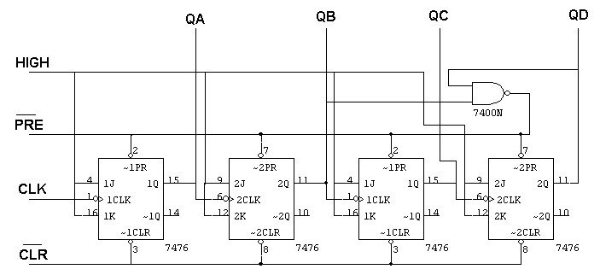

TRUTH TABLE

CLK | QA | QB | QC | QD
0 | 0 | 0 | 0 | 0
1 | 1 | 0 | 0 | 0
2 | 0 | 1 | 0 | 0
3 | 1 | 1 | 0 | 0
4 | 0 | 0 | 1 | 0
5 | 1 | 0 | 1 | 0
6 | 0 | 1 | 1 | 0
7 | 1 | 1 | 1 | 0
8 | 0 | 0 | 0 | 1
9 | 1 | 0 | 0 | 1
10 | 0 | 0 | 0 | 0

LOGIC DIAGRAM FOR MOD - 12 RIPPLE COUNTER

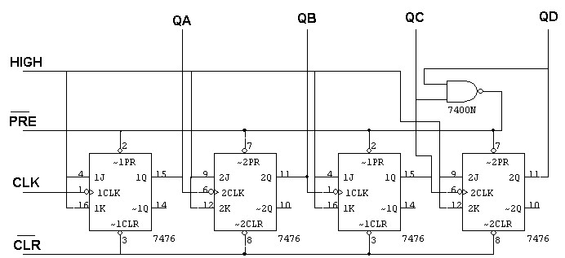

TRUTH TABLE

CLK | QA | QB | QC | QD
0 | 0 | 0 | 0 | 0
1 | 1 | 0 | 0 | 0
2 | 0 | 1 | 0 | 0
3 | 1 | 1 | 0 | 0
4 | 0 | 0 | 1 | 0
5 | 1 | 0 | 1 | 0
6 | 0 | 1 | 1 | 0
7 | 1 | 1 | 1 | 0
8 | 0 | 0 | 0 | 1
9 | 1 | 0 | 0 | 1
10 | 0 | 1 | 0 | 1
11 | 1 | 1 | 0 | 1
12 | 0 | 0 | 0 | 0

PROCEDURE

    - Connections are given as per circuit diagram.
    - Logical inputs are given as per circuit diagram.
    - Observe the output and verify the truth table.

RESULT:

Thus the various types of counter operations were performed successfully

EX.NO:7 DATE:

DESIGN AND IMPLEMENTATION OF 3 BIT SYNCHRONOUS UP/DOWN COUNTER

AIM

To design and implement 3 bit synchronous up/down counter.

APPARATUS REQUIRED

S.No. | COMPONENT | SPECIFICATION | QTY.
1. | JK FLIP FLOP | IC 7476 | 2
2. | 3 I/P AND GATE | IC 7411 | 1
3. | OR GATE | IC 7432 | 1
4. | XOR GATE | IC 7486 | 1
5. | NOT GATE | IC 7404 | 1
6. | IC TRAINER KIT | - | 1
7. | PATCH CORDS | - | 35

THEORY
A counter is a register capable of counting number of clock pulse arriving at its clock input. Counter represents the number of clock pulses arrived. An up/down counter is one that is capable of progressing in increasing order or decreasing order through a certain sequence. An up/down counter is also called bidirectional counter. Usually up/down operation of the counter is controlled by up/down signal. When this signal is high counter goes through up sequence and when up/down signal is low counter follows reverse sequence.

STATE TABLE

PRESENT STATE |  |  | NEXT STATE |  |  | FLIP-FLOP INPUTS
Q2 | Q1 | Q0 | Q2 | Q1 | Q0 | J2 | K2 | J1 | K1 | J0 | K0
0 | 0 | 0 | 0 | 0 | 1 | 0 | X | 0 | X | 1 | X
0 | 0 | 1 | 0 | 1 | 0 | 0 | X | 1 | X | X | 1
0 | 1 | 0 | 0 | 1 | 1 | 0 | X | X | 0 | 1 | X
0 | 1 | 1 | 1 | 0 | 0 | 1 | X | X | 1 | X | 1
1 | 0 | 0 | 1 | 0 | 1 | X | 0 | 0 | X | 1 | X
1 | 0 | 1 | 1 | 1 | 0 | X | 0 | 1 | X | X | 1
1 | 1 | 0 | 1 | 1 | 1 | X | 0 | X | 0 | 1 | X
1 | 1 | 1 | 0 | 0 | 0 | X | 1 | X | 1 | X | 1

3-BIT SYNCHRONOUS UP COUNTERS

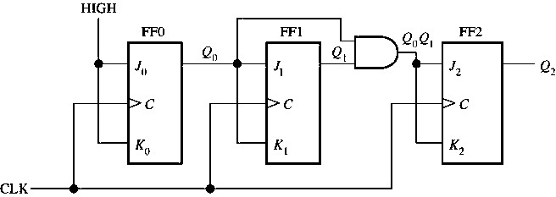

TABULATION

Clock | Q2 | Q1 | Q0
0 | 0 | 0 | 0
1 | 0 | 0 | 1
2 | 0 | 1 | 0
3 | 0 | 1 | 1
4 | 1 | 0 | 0
5 | 1 | 0 | 1
6 | 1 | 1 | 0
7 | 1 | 1 | 1

STATE TABLE

PRESENT STATE |  |  | NEXT STATE |  |  | FLIP-FLOP INPUTS
Q2 | Q1 | Q0 | Q2 | Q1 | Q0 | J2 | K2 | J1 | K1 | J0 | K0
1 | 1 | 1 | 1 | 1 | 0 | X | 0 | X | X | X | 1
1 | 1 | 0 | 1 | 0 | 1 | X | 0 | X | X | 1 | X
1 | 0 | 1 | 1 | 0 | 0 | X | 0 | 0 | 0 | X | 1
1 | 0 | 0 | 0 | 1 | 1 | X | 1 | 1 | 1 | 1 | X
0 | 1 | 1 | 0 | 1 | 0 | 0 | X | 0 | 0 | X | 1
0 | 1 | 0 | 0 | 0 | 1 | 0 | X | 1 | 1 | 1 | X
0 | 0 | 1 | 0 | 0 | 0 | 0 | X | X | X | X | 1
0 | 0 | 0 | 1 | 1 | 1 | 1 | X | X | X | 1 | X

3-BIT SYNCHRONOUS DOWN COUNTERS

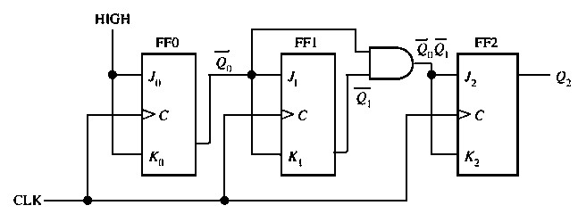

TABULATION

Clock | Q2 | Q1 | Q0
0 | 1 | 1 | 1
1 | 1 | 1 | 0
2 | 1 | 0 | 1
3 | 1 | 0 | 0
4 | 0 | 1 | 1
5 | 0 | 1 | 0
6 | 0 | 0 | 1
7 | 0 | 0 | 0

3-BIT SYNCHRONOUS UP/DOWN COUNTERS

TRUTH TABLE

Input  Up/Down | Present State  QA QB QC | Next State  QA+1 Q B+1 QC+1 | A  JA KA | B  JB KB | C  JC KC
0 | 0 0 0 | 1 1 1 | 1 X | 1 X | 1 X
0 | 1 1 1 | 1 1 0 | X 0 | X 0 | X 1
0 | 1 1 0 | 1 0 1 | X 0 | X 1 | 1 X
0 | 1 0 1 | 1 0 0 | X 0 | 0 X | X 1
0 | 1 0 0 | 0 1 1 | X 1 | 1 X | 1 X
0 | 0 1 1 | 0 1 0 | 0 X | X 0 | X 1
0 | 0 1 0 | 0 0 1 | 0 X | X 1 | 1 X
0 | 0 0 1 | 0 0 0 | 0 X | 0 X | X 1
1 | 0 0 0 | 0 0 1 | 0 X | 0 X | 1 X
1 | 0 0 1 | 0 1 0 | 0 X | 1 X | X 1
1 | 0 1 0 | 0 1 1 | 0 X | X 0 | 1 X
1 | 0 1 1 | 1 0 0 | 1 X | X 1 | X 1
1 | 1 0 0 | 1 0 1 | X 0 | 0 X | 1 X
1 | 1 0 1 | 1 1 0 | X 0 | 1 X | X 1
1 | 1 1 0 | 1 1 1 | X 0 | X 0 | 1 X
1 | 1 1 1 | 0 0 0 | X 1 | X 1 | X 1

K MAP

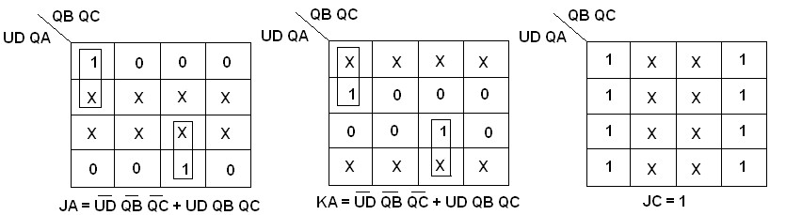

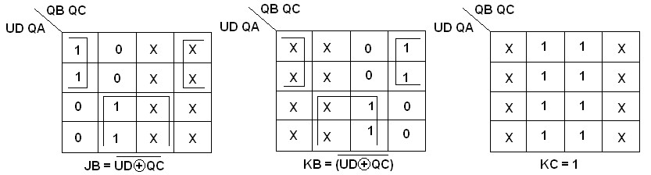

LOGIC DIAGRAM

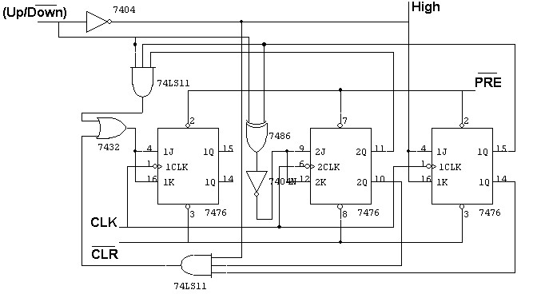

CHARACTERISTICS TABLE

Q | Qt+1 | J | K
0 | 0 | 0 | X
0 | 1 | 1 | X
1 | 0 | X | 1
1 | 1 | X | 0

RESULT:

Thus the various types of synchronous counter operations were performed successfully

EX.NO:8 DATE:

IMPLEMENTATION OF SISO, SIPO, PISO AND PIPO SHIFT REGISTERS

AIM

To implement the 4 bit shift register using flip flops and to study the operations in the
following modes.
    - Serial in serial out
    - Serial in parallel out
    - Parallel in parallel out.

APPARATUS REQUIRED

S.No. | Name of the apparatus | Range | Quantity
1 | Digital Trainer kit |  | 1
2 | D Flip Flop | IC 7474 | 2
3 | Connecting wires |  | some

SHIFT REGISTER

A register is a device capable of storing a bit. The data can be serial or parallel. The register
can convert a data from serial to parallel and vice versa shifting then digits to left and right is the important aspect for arithmetic operations,
A register capable of shifting its binary information either to the right or to the left is called a shift register. An N bit shift register consists of N flip-flops and the gates that control the shift operation. A shift register can be used in four different configurations depending upon the way in which the data are entered into and taken out of it. These four configurations are:
Serial-input, Serial-output
Parallel-input, Serial-output
Serial-input, parallel-output

PROCEDURE
- The flip-flop is connected using connecting wires as shown in the circuit.
- The flip flop are then reset to zero internally with the help of reset to set inputs.
- The bits are shifted in by giving suitable clock input.
- Thus the truth table is then verified.

PIN DIAGRAM OF IC7474

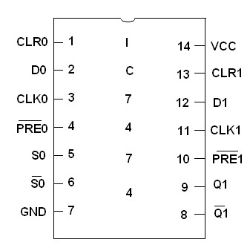

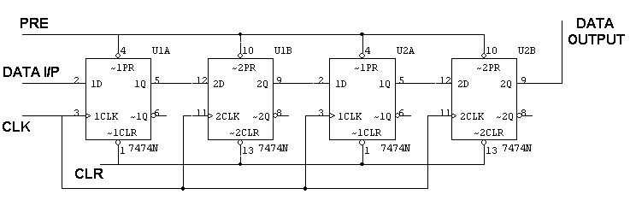SERIAL IN SERIAL OUT

TRUTH TABLE

Clock | Serial in | Serial out
1 | 1 | 0
2 | 0 | 0
3 | 0 | 0
4 | 1 | 1
5 | X | 0
6 | X | 0
7 | X | 1

SERIAL IN PARALLEL OUT

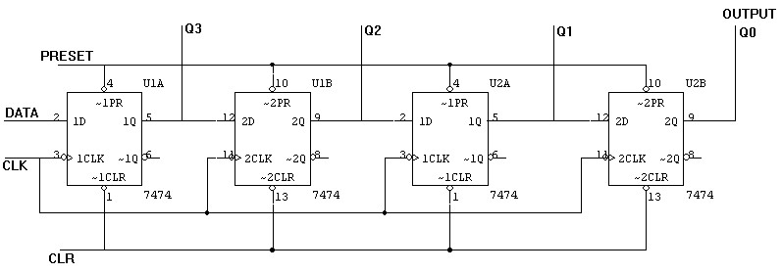

TRUTH TABLE

CLK | DATA | OUTPUT
CLK | DATA | QA | QB | QC | QD
1 | 1 | 1 | 0 | 0 | 0
2 | 0 | 0 | 1 | 0 | 0
3 | 0 | 0 | 0 | 1 | 1
4 | 1 | 1 | 0 | 0 | 1

PARALLEL IN SERIAL OUT MANUAL MODE
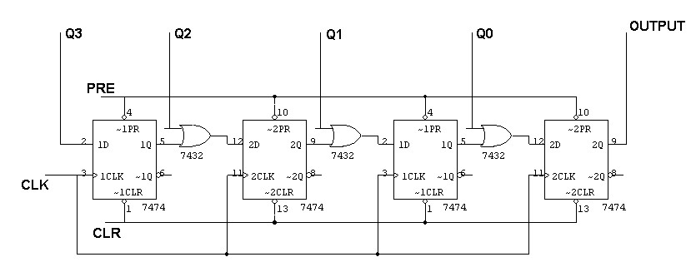

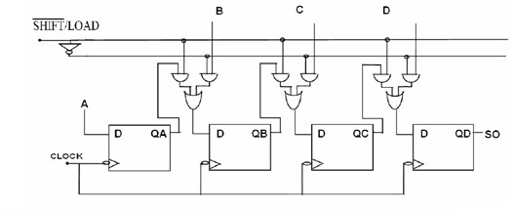PARALLEL IN SERIAL OUT

PARALLEL IN SERIAL OUT USING NAND GATE

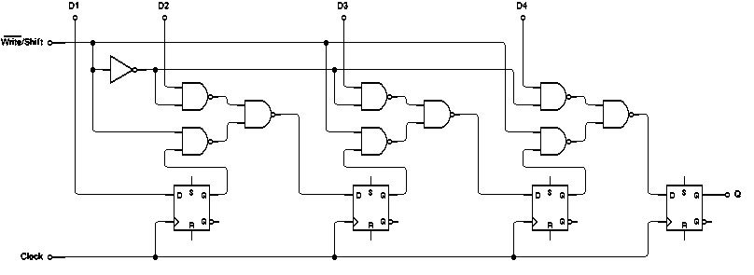

TRUTH TABLE:

CLK | Q3 | Q2 | Q1 | Q0 | O/P
0 | 1 | 0 | 0 | 1 | 1
1 | 0 | 0 | 0 | 0 | 0
2 | 0 | 0 | 0 | 0 | 0
3 | 0 | 0 | 0 | 0 | 1

PARALLEL IN PARALLEL OUT

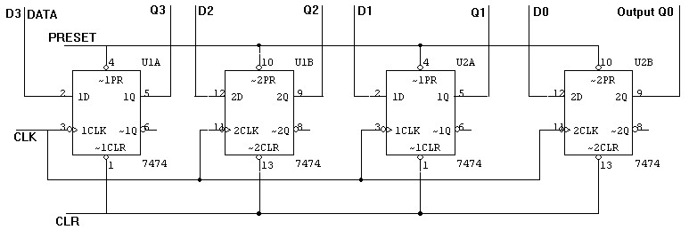

TRUTH TABLE

CLK | DATA INPUT |  |  |  | OUTPUT
CLK | DA | DB | DC | DD | QA | QB | QC | QD
1 | 1 | 0 | 0 | 1 | 1 | 0 | 0 | 1
2 | 1 | 0 | 1 | 0 | 1 | 0 | 1 | 0

RESULT:
Thus the various types of Shift register oper ations were performed and verified successfully

